**Improving Liveability- Better Recreational Spaces**

The liveability of communities and neighborhoods can be improved by enhancing the quality of recreational spaces and schools. In cities with a high population, it is often difficult to find available land to create recreational spaces such as parks. Recreational spaces provide important health benefits because they give people somewhere to exercise and relax. Also, fresh air has many health benefits.

One city that is well known for its transformation of vacant (free) land into parks is New York. The city is most famous for its buildings and large Central Park. Since 2011, it has also become known as a city with an elevated park. The High Line park, which stretches 2.3km, used to be an elevated railway line built in the 1920’s. Because it was no longer being used, the mayor had plans to demolish the railway line. Instead, US$115 million was spent to convert it to an elevated park. The park has lawns and forested areas, along with places for people to sit and relax. The High Line park allows people in New York to escape the busy, noisy city life and enjoy being in nature.

(Adapted from *Humanities and Social Sciences 7*- Pearson, 2017, p. 131-132)

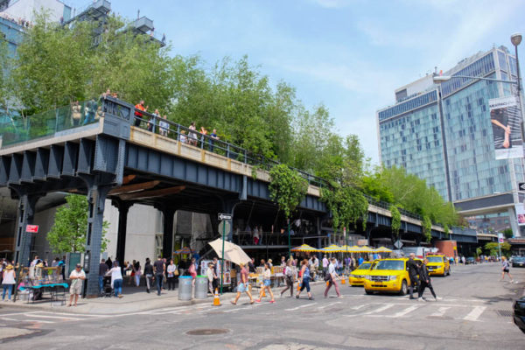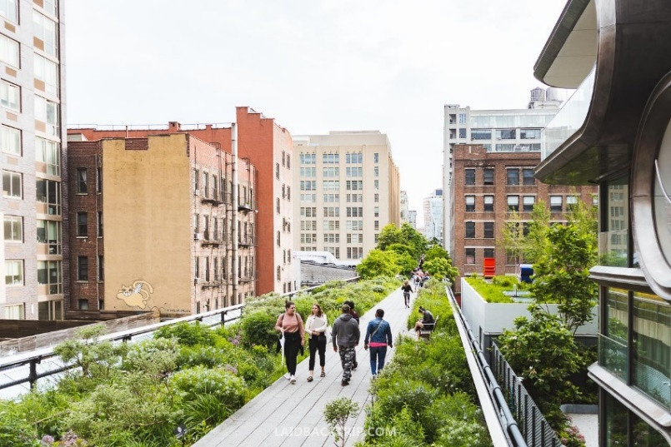

**Improving Liveability- Better Recreational Spaces**

The liveability of communities and neighborhoods can be improved by enhancing the quality of recreational spaces and schools. In cities with a high population, it is often difficult to find available land to create recreational spaces such as parks. Recreational spaces provide important health benefits because they give people somewhere to exercise and relax. Also, fresh air has many health benefits.

One city that is well known for its transformation of vacant (free) land into parks is New York. The city is most famous for its buildings and large Central Park. Since 2011, it has also become known as a city with an elevated park. The High Line park, which stretches 2.3km, used to be an elevated railway line built in the 1920’s. Because it was no longer being used, the mayor had plans to demolish the railway line. Instead, US$115 million was spent to convert it to an elevated park. The park has lawns and forested areas, along with places for people to sit and relax. The High Line park allows people in New York to escape the busy, noisy city life and enjoy being in nature.

(Adapted from *Humanities and Social Sciences 7*- Pearson, 2017, p. 131-132)

